Accessible Math

Format types
- HTML + MathML = OER content, LMS content
  - Native support for MathML
  - Works well with screen readers
  - Supports refreshable braille displays
  - Reflowable and responsive
  - Easily zoomed without loss of information
  - Supports semantic math navigation
- EPUB 3 + MathML = Textbook
  - Excellent screen reader support
  - Supports MathML
  - Reflowable
- Word (.docx) with native equations = Course handout
  - Easy for faculty to create
  - Supports native equation objects
  - Can be converted to accessible formats
  - Works reasonably well with modern screen readers
- Tagged PDF 2.0 with accessible math = Published content

Creating documents

HTML
- Create the page with semantic HTML structure: title, headings, lists, tables, and landmarks.
- Add equations using MathML:
  - Create equations directly in MathML or convert equations from LaTeX, MathType, or another equation editor into MathML.
  - Insert MathML using the <math> element and related MathML tags.
  - Ensure mathematical structures such as fractions, superscripts, subscripts, square roots, matrices, and summations are represented with appropriate MathML markup rather than plain text.
  - Verify that equations can be interpreted by screen readers.
  - Avoid using images or screenshots of equations whenever possible.
- Add descriptions for graphs, charts, and diagrams.
- Ensure text and math can reflow and resize.
- Check color contrast and avoid using color alone.
- If an equation must be an image, provide accurate alt text.
- Test with keyboard navigation and a screen reader.

EPUB
- Build the EPUB using EPUB 3 standards.
- Use semantic HTML for chapters, headings, lists, tables, and landmarks.
- Add equations using MathML:
  - Create equations in MathML or use a tool that exports equations as MathML.
  - Embed MathML directly within the EPUB content files (XHTML).
  - Verify that mathematical structures such as fractions, radicals, matrices, summations, and integrals are preserved as MathML rather than converted to images.
  - Test the EPUB in reading systems that support accessible MathML.
  - Confirm that screen readers can access and interpret the equations correctly.
  - Avoid using images of equations unless absolutely necessary.
- Include a complete EPUB Navigation Document/table of contents.
- Add alt text or long descriptions for images, charts, and graphs.
- Add accessibility metadata.
- Make sure text is reflowable and resizable.
- Validate accessibility.

Word Document
- Start with an accessible Word document structure: title, headings, lists, and tables.
- Insert equations using Word’s built-in Equation Editor, MathPix or MathType.
- Do not paste equations as screenshots or images.
- Use LaTeX input inside Word’s Equation Editor when helpful.
- Add alt text or descriptions for graphs, charts, and diagrams.
- Set the document language.
- Run Word’s Accessibility Checker.
- Test equations with assistive technology when possible.

Tagged PDF
- Start from an accessible source file, such as Word, HTML, or LaTeX with structured math.
- Export to PDF 2.0 using the “Save As” option to preserve tags and document structure.
- Confirm the PDF is tagged.
- Check that equations remain accessible and are not flattened into images.
- Verify heading tags, reading order, lists, tables, links, and document language.
- Add alt text or long descriptions for graphs and diagrams.
- Test with Adobe Acrobat Accessibility Checker and screen reader review.

Remediating documents

Step 1: Decide on approach
If possible, remediate from original source document
- Mostly text, a few simple equations: Remediate the PDF
- STEM textbook, problem set, research article, engineering manual: Recreate the document from scratch
- Scanned PDF with equations: Recreate the document from scratch

Step 2: Extract text
Use OCR if necessary. Not all software is created equal and can accurately identify and OCR math. Some software options include: MathPix, MathKicker AI, Equatio

MathPix Webapp
Use this for full PDF conversion.
- Launch the Mathpix Snip Webapp tool or the desktop app
- Upload the PDF that you would like to convert.
  - Navigate to the PDF Tool and then click on the plus sign (+) in the selection panel to select and open the PDF file. If needed – you can upload multiple documents at a time.
- Once the PDF file is uploaded, it may need a few minutes to fully process the document.
- Once the document is done, select the menu options
- From the Export menu, select the needed file option.
  - Options include: Word, HTML, LaTeX, MarkDown
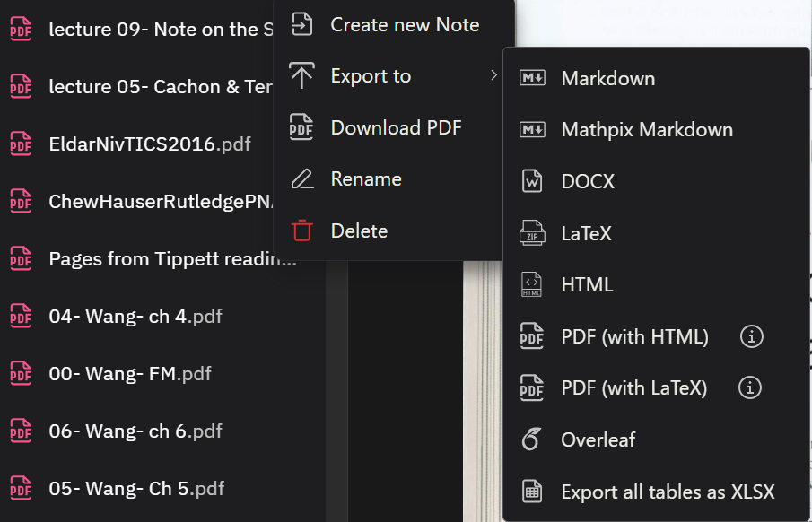

Step 4: Rebuild the document
Input standard accessibility features like any other document type.
- Title
- Headings
- Lists
- Tables

Step 5: Edit math content
Work your way through the document, double checking the equations as you go. Make sure that the equations converted correctly. You can utilize Microsoft Word’s equation editor alongside MathPix to build documents with accessible math. In some rare cases, the student may want the document in LaTeX or a PDF with equations tagged appropriately and accompanied by a MathML file. Depending on what you’re using to recreate the document, use the appropriate editor.
- LaTeX: Texstudio, Overleaf, etc.
- Word: Word Equation Editor, MathType. Use MathPix Snip to grab those few equations that didn’t convert properly the first time.

MathPix Snip
Use this when you already have the Word version available and need to insert accessible equations.
- Launch the Mathpix Snip Webapp tool.
- Take a screenshot of the math equation or section of math that requires alternate text.
- Review the image rendered by Mathpix to make sure that it accurately displays all of the information from the original image.
  - If needed, use the editing feature in the top right-hand corner to revise the LaTeX code and text.
- Copy the option “MathML for Word” into your Word document

Editing math in Word
Once in Word, you can edit both the equations and the surrounding content ensuring that every aspect of document is accessible, including alt text tags, headings and tables. Review the instructions for remediating Word documents for accessibility.
- Edit the equation as needed using Microsoft’s equation editor
- To access more symbols, open the symbol pane to switch between options
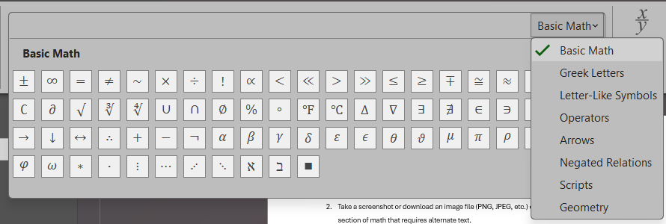
- Can’t find a symbol or want to type in LaTeX? Review this list of different AutoCorrect Codes developed by the University of Houston to help get you started.

Step 6: Create accessible graphs and diagrams
Add alt text and long descriptions when needed

Step 7: Run accessibility checkers
- Review equations
- Review all aspects of document accessibility

Step 8: Export to final format
Once recreated, export the document to the appropriate file format.

From Word to PDF
- Navigate to File – Save As PDF.
- Once you’ve selected PDF as the file option, open the “More options” link.
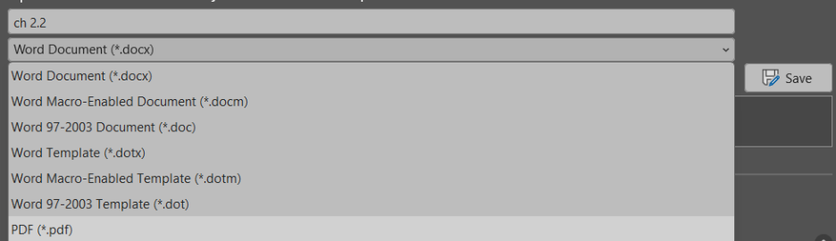
- In the section for “Include non-printing information” select the headings checkbox for bookmarks and the checkbox for “Document structure tags for accessibility”. Other methods of exporting or saving as PDF do not give you this option and do not appear to produce a PDF with the correct “Formula” tags for the equations.
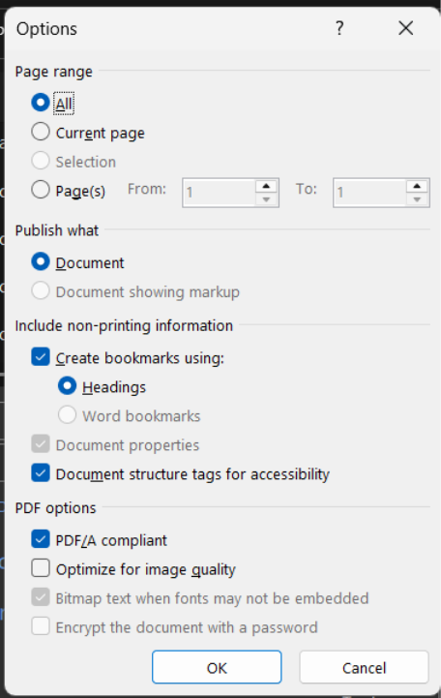

Using the Word-to-EPUB plug-in
- Navigate to the DAISY add-in “WordtoEPUB”.
- Ensure filename and file location are correct.
- Open the Advanced setting and be sure to select all the appropriate settings for the document.
  - Metadata: title, author, publisher, etc.
  - Cover image: select a cover image or choose not to do a cover image at all
  - EPUB options: language and table of contents options
  - Page numbers: if the end format is EPUB – choose the option that makes the most sense in order for the original page numbers to transfer over. A simple option is to use the “print” option. Replace all the page numbers in the Word document to say “PRINT PAGE #” before going ahead with this option.
  - Styling: options for styling and style sheets
  - Headings: preview of the navigable heading outline

ePub
- Navigate to the Math tab in the advanced settings. Ensure the option for MathML is selected.
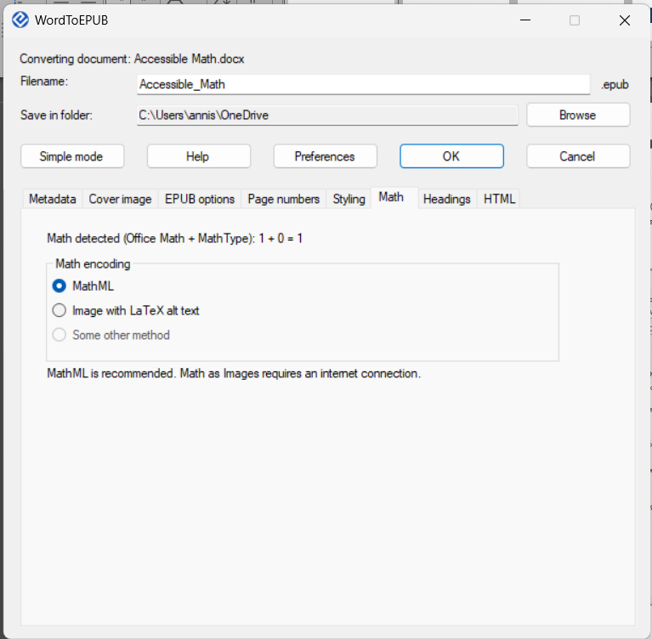
- Once all of the settings are correct and confirmed – select the “OK” button and let the add-in process the document.
- Review the final document within the ePub reader, ensuring all accessibility features are working correctly.

HTML
- Navigate to the HTML tab in the advanced settings. Ensure the box for “Include MathJax reference” is checked.
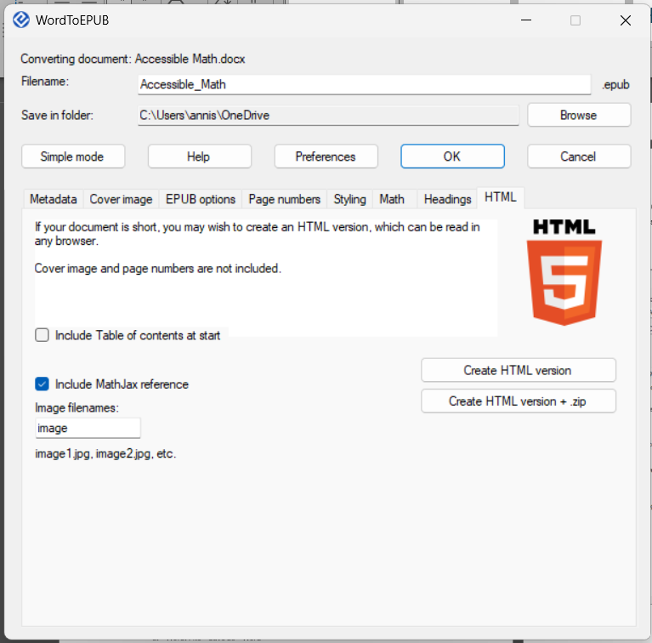
- Once all of the settings are correct and confirmed – select the “Create HTML version” button and let the add-in process the document.
- Review the final document within HTML, ensuring all accessibility features are working correctly.

Resources
Introduction to Math Accessibility - The Accessibility Guy
Accessible Math Unlocks STEM Education and Careers - DAISY Consortium

Software
- MathKicker
- Mathpix
- MathType
- Pandoc Conversion Utility
- Download WordToEPUB | The DAISY Consortium
- Getting started with WordToEPUB | The DAISY Consortium
- MathML Support in Microsoft 365 | Microsoft Learn
- Typing Math in Microsoft Word | University of Houston
- Accessible math in PDF | PDF Association
- Math converter tool | Indiana University
- JamA11y | Jamworks Help Center - remediation tool with MathType built in
- Converting Documents to PDF | WebAim

Images
- Charts & Diagrams Alt Text - Digital Accessibility | University of South Carolina
- Effective Practices for Description of Science Content | GBH
- Image Description Guidelines | DIAGRAM Center

LaTeX
- Learn LaTeX | learnlatex.org
- Learn LaTeX | Overleaf
- Mathematical expressions | Overleaf
- Accessibility checklist for LaTeX documents | ASK - Lancaster University
- Making Accessible Documents Using LaTeX
- Generating tagged PDF from LaTeX
- LaTeX-cheat-sheet.pdf | UOregon
- LaTeX Mathematical Symbols | Rice University
- Cheatsheet for LaTeX Math Commands | Tilburg Science Hub
- Mathematics in LaTeX - LaTeX and Overleaf | UChicago
- LaTeX Support in Microsoft 365 | Microsoft Learn
- From LaTeX to accessible PDFs | Microsoft 365

TTS Readers
- Microsoft ReadAloud (better for simple docs)
- Central Access Reader | Central Washington University
- Kurzweil (epub w/ MathML or OCR lasso tool)
- Equatio (OCR lasso tool – more of an author tool)

Videos
- Turning Math Into HTML
- Using Pandoc
- Pandoc how to convert from LaTeX beemer to HTML
- Math Accessibility playlist
- Accessible Math and Science in Digital Publications
- Math in a PDF is now possible!
- Center for Assistive Technology Training playlist
- Accessible Math in PDF | PDF Association

